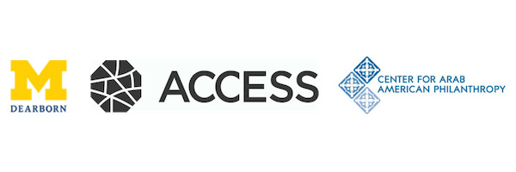

**The Dr. Adawia Alousi STEM Scholarship Fund for Muslim Women**  
 Deadline: 11:59 pm on Sunday, April 30th, 2023

**About the Scholarship:**

The Dr. Adawia Alousi STEM Scholarship Fund for Muslim Women was established in order to carry on the accomplishments of Dr. Adawia Alousi, a true renaissance woman. The Fund supports Muslim women in obtaining education within STEM (science, technology, engineering, and mathematics) fields – placing highest priority on immigrants and refugees. Our hope is that beneficiaries of the Fund will rise to the top, epitomize excellence in their respective fields, and carry Dr. Alousi’s spirit of generosity forward.

It is anticipated that the Dr. Adawia Alousi STEM Scholarship for Muslim Women will be between $2,500 and $10,000 per student for undergraduates and graduate students. The scholarship may be renewable for students maintaining satisfactory academic performance. The Fund will make all grant distributions directly to the student’s affiliated college or university. All colleges and universities must be accredited and be located within the United States. Our current acceptance rate is 15% for new applicants.

You can learn more about Dr. Adawia Alousi and the STEM Scholarship Fund at: <http://www.centeraap.org/funds/view-our-funds/dr-adawia-alousi-stem-scholarship-fund-muslim-women/>

**Eligibility and Requirements:**

* Be accepted into a STEM program at an accredited university in the United States
* Identify as a Muslim woman
* Demonstrate financial need and have a completed FAFSA on file with the institution’s Financial Aid Office
* GPA and Test Scores:
  + For incoming freshman, high school GPA of 3.6 or higher; due to COVID-19 affecting the ability for SAT testing, test scores will be optional
  + For currently enrolled undergraduate students: cumulative GPA of 3.5 or higher
  + For graduate students: cumulative GPA of 3.4 or higher
* List research experience and/or service activities in community, including work done through student organizations
* Agree to provide career data upon graduation

**Application:**

1. Fill out the application form online: <http://www.centeraap.org/grants/scholarships/dr-adawia-alousi-scholarship-fund-application/>
2. Submit a personal statement, two letters of recommendation from non-family members, an up-to-date Student Aid Report, most recent transcript, and a resume or CV through the online form.

**Personal Statement**

Submit an essay of *no more than three 8.5” x 11” typed, double-spaced pages, size 12 font, with 1-inch margins* describing the following:

* Career aspirations
* Reasons for choosing a STEM field
* Your financial need (i.e. are you the first to attend college in your family? Do you have any special circumstances you would like the scholarship committee to consider?)
* How you see yourself contributing in a unique way as a Muslim woman in the STEM field, and how you will carry forward Dr. Alousi’s spirit
* What impact being an Adawia Alousi Scholar would have on you
* Research experience, leadership and volunteer activities in your community and/or school

**Student Aid Report (SAR)**

Complete the Free Application for Federal Student Aid (FAFSA) and submit a PDF copy of your federal SAR with your Alousi Scholarship application.

**Letters of Recommendation**

Submit 2 non-family letters of recommendation. Each letter must be on official letterhead and signed. Your recommender must explain their relationship to you and provide their contact information within the letter. If your recommenders prefer to deliver their letters directly to the Alousi Scholarship Committee without you reading them, please instruct them to do so at this link: <https://www.centeraap.org/scholarship-letter-of-recommendation-form/>

**High School or College Transcript**

Submit a PDF copy of your high school or most recent college transcript grade report (unofficial OK).

**Resume or Curriculum Vitae**

Submit a resume or CV that lists any work and/or volunteer experiences you’ve had. Also include any honors or awards you have received.

**Scholarship Deadline: 11:59 pm on Sunday, April 30, 2023.**

If you have additional questions, please review our FAQ page below: <http://www.centeraap.org/grants/scholarships/dr-adawia-alousi-scholarship-fundapplication/alousi-scholarship-faq-page/>

If you still have questions, please direct them to [mcox@accesscommunity.org](mailto:mcox@accesscommunity.org).