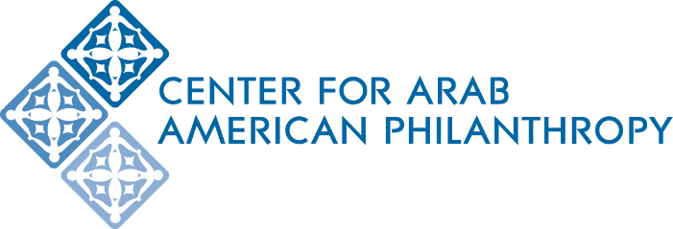
Kayal Scholarship Fund for Arab American Students in the Social Sciences
Housed at the Center for Arab American Philanthropy (CAAP)

Scholarship Deadline: 11:59pm on Sunday, July 17th, 2022

About the Scholarship
The Kayal Scholarship for Arab American Students in the Social Sciences supports exceptionally driven and talented first or second generation Arab American/MENA students studying a social science, with preference to students being the first in their family to attend college. It is anticipated that scholarships will be $1,000-$2,500 per student and may be renewable for up to four years for students who meet the University’s satisfactory academic progress standards for scholarships. The fund will make all grant distributions directly to the student’s affiliated college or university. All colleges and universities must be accredited.

The story behind the Kayal Scholarship Fund
Dr. Philip M. Kayal is a leading scholar on Arab American studies and currently a Professor Emeritus in the Department of Sociology and Anthropology at Seton Hall University in New Jersey. He is passionate about supporting the next generation of Arab Americans entering the social science fields.

Eligibility and Requirements:
- Must be currently enrolled or accepted into an undergraduate program at an accredited university or college located in either New Jersey, USA or NYC-Metro area, USA
- Must be a first or second generation Arab American (or identify as MENA)
- Must be majoring in a social science
- Must demonstrate financial need
- Preference is given to students who are first in their family to attend college
- Must maintain a GPA of 3.5 or higher
- Must agree to provide career data upon graduation

Application:
- Fill out the application form online: https://www.centeraap.org/grants/scholarships/kayal-scholarship-fund-for-arab-american-students-in-the-social-sciences/
- Submit a personal statement, two letters of recommendation from non-family members, an up-to-date Student Aid Report and/or statement of financial hardship, a copy of your high school or most recent college transcript, and a resume or CV through the online form

Personal Statement
Submit an essay of no more than two 8.5” x 11” typed, double-spaced pages, size 12 font, with 1-inch margins describing the following:
- Career aspirations
- Reasons for choosing the social science field
- What impact would being supported by the Dr. Philip M. Kayal Scholarship Fund have on you
- Leadership and volunteer activities in your community

Letters of Recommendation
Submit 2 non-family letters of recommendation. Each letter must be signed and on official letterhead. Your letter writer must explain their relationship to you and provide their contact information within the letter. If your recommenders prefer to deliver their letters directly to the Kayal Scholarship Decision Committee, please instruct them to do so at this link: http://www.centeraap.org/scholarship-letter-of-recommendation-form/

Student Aid Report (SAR) and/or Statement of Financial Need
Please complete the Free Application for Federal Financial Aid (FAFSA) application and submit a PDF copy of your federal SAR with your application. If you need help filling out the FAFSA form, please contact the college or university’s Office of Financial Aid.

Statement of Financial Hardship
Financial hardship occurs when a person or family struggles to make payments toward debt or bills or have expendable funds for things like college tuition. The statement of financial hardship will be entered in the online application form; your response is kept confidential. Your statement must be 1-2 sentences demonstrating your financial hardship, such as, “My parents are challenged making ends meet due to providing for myself, my siblings, as well as my grandmother who lives in the basement.”

High school or College Transcript
Please upload a copy of your high school transcript (unofficial OK) or most recent college transcript (unofficial OK). If you wish to submit your transcripts directly, please mail to:
CAAP
Kayal Scholarship Committee
2651 Saulino Court
Dearborn MI 48120

Resume or Curriculum Vitae
Submit a resume or CV that lists any work and/or volunteer experiences you’ve had. Also include any honors or awards you have received.

Scholarship Deadline: 11:59 pm on Sunday, July 17th, 2022

Please direct any questions to Mikala Cox at mcox@accesscommunity.org.

