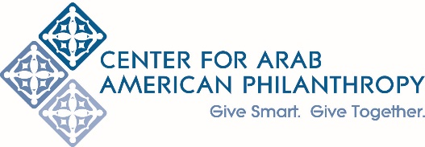
2022 Request for Letters of Inquiry (LOI)
Deadline: March 11, 2022 at 11:59 pm EST

Background and Need

The Center for Arab American Philanthropy (CAAP) is a national community foundation. An institution of ACCESS, CAAP’s objective is to unite and empower the Arab American community by demonstrating the impact of giving together. CAAP is not only engaged in strengthening individual philanthropy in the Arab American community, but is committed to strengthening Arab American community organizations around the country. Strong organizations are essential for the development and empowerment of the Arab American community as a whole. Learn more at www.centeraap.org

The National Network for Arab American Communities (NNAAC) is a national consortium of independent Arab American community organizations based in the U.S. - and the only network of its kind. An institution of ACCESS, since its inception NNAAC has prioritized building capacity of its member organizations through its Capacity Building program, which provides organizational development services with the goal of strengthening and empowering member organizations to be more stable, well-managed nonprofit organizations.

As one of the few institutional funders that focuses our competitive grantmaking programs on the Arab American community, CAAP is aware of the current financial realities facing Arab American community organizations and the need for ongoing operational support to build long-term sustainability. While NNAAC historically has funded capacity building projects through its annual grantmaking program, due to the ongoing challenges facing Arab American community organizations due to the COVID-19 pandemic, NNAAC recognizes the importance this year of providing general operating support to member organizations.

Funding Priorities

To streamline our processes and ease the burden on applicants, CAAP and NNAAC have opted this year to combine our grantmaking and offer general operating support grants. CAAP and NNAAC will award grants up to a maximum of $10,000 each for Arab American organizations that fall within the following two focus areas: Arts, Culture & Media OR Human Services, Education & Advocacy. We will announce the awards by July 2022, with the grant period starting July 1, 2022 and ending June 30, 2023. Organizations awarded grants may be eligible for future funding opportunities through CAAP and/or NNAAC, as available.

Eligibility

To be eligible for funding, your organization MUST:
- Be a U.S. based Arab American nonprofit serving the Arab American community. CAAP and NNAAC define an Arab American nonprofit as an organization that self-identifies as Arab American, and has a majority Arab American representation among the leadership of the organization and the populations served.
- Currently have valid 501(c)(3) status with the IRS.

NOTE:
1) Prior grantees who have failed to submit required reports for previous grants will not be eligible to apply.
2) NNAAC’s available funding will only support NNAAC member organizations. CAAP’s available funding will support either NNAAC member organizations or other Arab American organizations that meet the requirements listed above.

Application Process

Eligible organizations are welcome to submit a letter of inquiry through our website by March 11, 2022 at 11:59 pm EST. CAAP and NNAAC will review all submitted LOIs, and determine which organizations will be invited to submit a full proposal by April 5, 2022.

Questions? Please contact:

Katherine Asuncion
Donor Services and Program Officer, CAAP
Kasuncion@accesscommunity.org

Bryn Prater
Capacity Building Specialist, NNAAC
Bprater@accesscommunity.org

