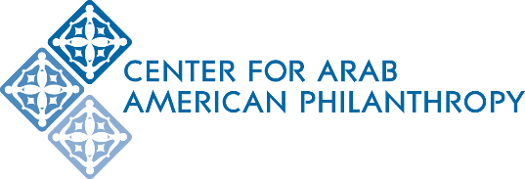
The Khalaf Family Scholarship Application for Arab American Students Studying Engineering
Scholarship Deadline: 11:59 pm on Sunday, February 17, 2019

About the Scholarship
It is anticipated that the Khalaf Family Scholarships will be $2,500 per student and may be renewable for up to 4 years for students meeting satisfactory academic progress standards. The Fund will make all grant distributions directly to the student’s affiliated college or university. All colleges and universities must be accredited.

Eligibility and Requirements:
- Be enrolled or accepted in an engineering program at an accredited college or university in the state of Michigan
- Be of Arab American heritage
- For high school seniors, must have a cumulative GPA of 3.6 or higher and ACT score of 24 or higher, or SAT score of 1160 or higher
- For currently enrolled undergraduate students, must have a cumulative GPA of 3.2 or higher
- Must agree to provide career data upon graduation
- Must demonstrate financial need
Application:
- Fill out the application form online: http://bit.ly/khalafscholarship
- Submit a personal statement, two letters of recommendation from non-family members, an up-to-date Student Aid Report, and a resume or CV through the online form.
Personal Statement
Submit an essay of no more than two 8.5” x 11” typed, double-spaced pages, size 12 font, with 1-inch margins describing the following:
- Career aspirations
- Reasons for choosing the career goal(s) and your preparation for career
- How you see yourself contributing in a unique way given your heritage
- What impact being a Khalaf Scholar would have on you
- Leadership and volunteer activities in your community and/or school

Student Aid Report (SAR)
The Free Application for Federal Financial Aid (FAFSA) is already open for the 2019-2020 school year. Complete the application and submit a PDF copy of your federal SAR with your Khalaf Scholarship application. If you need help filling out the FAFSA form, please contact the college or university’s Office of Financial Aid.

Letters of Recommendation
Submit 2 non-family letters of recommendation. Each letter must be signed and on official letterhead. Your letter writer must explain their relationship to you and provide their contact information within the letter. If your recommenders prefer to deliver their letters directly to the Khalaf Scholarship Committee without you reading them, please instruct them to do so at this link: https://goo.gl/uDZiGK

Resume or Curriculum Vitae
Submit a resume or CV that lists any work and/or volunteer experiences you’ve had. Also include any honors or awards you have received.

- Mail an official, most recent transcript from your school to:
CAAP
Khalaf Scholarship Committee
2651 Saulino Court
Dearborn MI 48120

Scholarship Deadline: 11:59 pm on Sunday, February 17, 2019

Please direct any questions to Marwa Harp at marwaharp@accesscommunity.org or 313-842-4754.

